Second meeting for sprint 2 (Team 77)

## Meeting date | time Date | Time | Meeting location Location

## 05/10/18 3pm-4pm S-Block (S502)

|  |  |  |  |  |  |  |  |
| --- | --- | --- | --- | --- | --- | --- | --- |
| |  |  | | --- | --- | | Meeting called by | Keonwoo Lee | | Note taker | Keonwoo Lee | | Timekeeper | Keonwoo Lee | | Attendees  Keonwoo Lee, Dipper Dai, Yiming Pan, Anqi Cui  Non-Attendees  - |

Discussion Conversation

The purpose of having today’s meeting is to check the progress of week 10’s sprint 2 activities done by each team member and to lay another plan for week11’s sprint 2 activities based on the retrospect.

**Week10’s sprint 2 activities done**

* Story 24: History/Data manage (Edit)
* Our original plan for story 24 was to have such functionality in the “History” menu but the editing function is now established in the “Record” menu
* The company user can now edit and delete data (customer and order info)

T**o do list for week11’s sprint 2 activities – focused on story 25: History/Data Manage (Load new data)**

|  |  |  |
| --- | --- | --- |
| Action items | Person responsible | Deadline |
| **Topic 1** Create a prototype for window page that helps user load new data from the database and verify story is complete (related to task ID T30, T36) | Keonwoo Lee | 09/10/18 |
| **Topic 2** Start building a user manual for the web application since 70% of the release has been completed | Dipper Dai | - |
| **Topic 3** Write code to enable the button “Load Data” to bring up a window page that loads new data from the database (related to task ID T32,33) | Yimming Pan | 09/10/18 |
| **Topic 4** Create a button “Load Data” and Write test cases (related to task ID T31, T35) | Anqi Cui | 09/10/18 |

**Special notes Type additional notes here**

* Task ID T34 (Write code to list the loaded data in a tabular format) seems unnecessary since it is expected that the loaded data will be automatically added into the original table

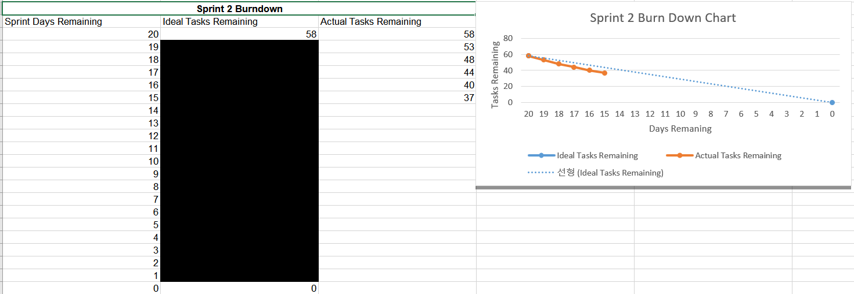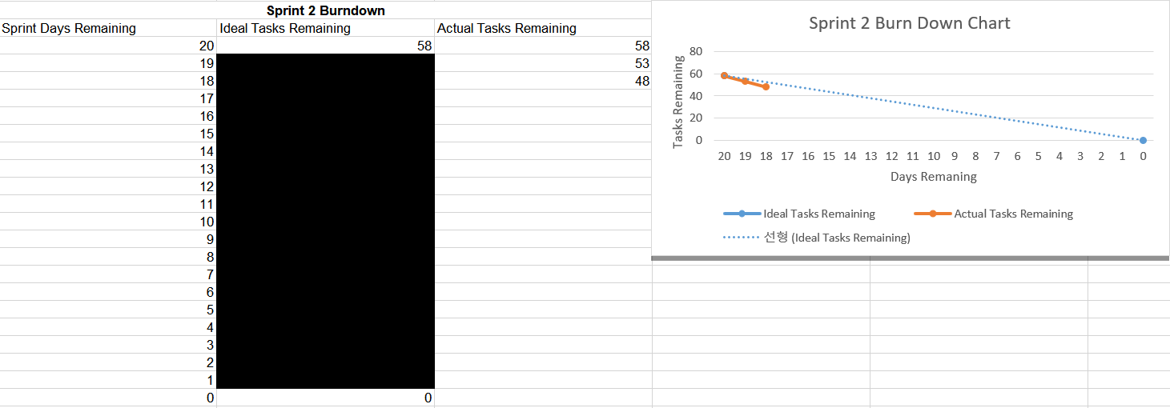**Burndown chart up to date**

**Next meeting:** 09/10/18 Tuesday 2pm-3pm